Faculty Senate

Academic Programs Committee

Report for February 13, 2024 Senate Meeting

The following four proposals need to be reviewed by the Academic Programs Committee.

CLICK (or ENTER) this URL.

https://nextcatalog.utoledo.edu/programadmin/

COPY & PASTE this comma-delimited list into CIM programs search box.

SM-MEDL-BS, SM-ENSC-BS, SM-DSCI-BS-INDV, SM-BIOL-BS, *Semiconductors*, *Materials Science*, AR-GEOG-BA, AR-MUSC-BM-GUIT, HH-CRIN-BSJ

Disregard anything that does not have FACULTY SENATE PROGRAMS in the workflow.
There should be 12 proposals to review.

The full instruction sheet, with images, is still included at the end of this document.

Program Modifications

Natural Sciences and Mathematics

Biology - Biology Ecology and Organismal Biology Concentration, BS

Adding a combined bachelor's to master's pipeline programs, as follows:

Combined bachelor's to master's - Biology/ Ecology and Organismal Biology BS (with a minor in either Env. Biology or Geology) to Environmental Science, MS Pipeline Program that permits undergraduate BIOM students to enroll and complete up to 9 hours of graduate courses before completing their undergraduate degree.

No new or modified courses.

SM-DSCI-BS-INDV : Data Science - Individualized Concentration, BS

Adding a combined bachelor's to master's pipeline programs, as follows:

Combined bachelor's to master's - Environmental Science BS to Environmental Science, MS Pipeline Program that permits undergraduate ENSC students to enroll and complete up to 9 hours of graduate courses before completing their undergraduate degree.

No new or modified courses.

Environmental Sciences, BS

Adding a combined bachelor's to master's pipeline programs, as follows:

Combined bachelor's to master's - Environmental Science BS to Environmental Science, MS Pipeline Program that permits undergraduate ENSC students to enroll and complete up to 9 hours of graduate courses before completing their undergraduate degree.

No new or modified courses.
Medical Laboratory Science, BS

1. To bring required credits hours and time to degree into line with other local and regional MLS programs. The UToledo MLS program currently requires 143 credit hours to complete, and takes between 9 and 10 semesters for students to complete. Most other programs require 120 credits, and we require 9 credits more than the only other program over 120 credits. These additional credits result in additional semester(s) of study and tuition costs for our students and can have impacts on their financial aid.

2. To better align the curriculum with successfully completing the ASCP BOC certification exam demonstrating that the student has obtained the essential knowledge and skills for competent practice as a Medical Laboratory Scientist. Currently our graduating students struggle in their performance on this exam. By modernizing the sequence and amount of weight (credit hours of instruction) of the pre-clinical and clinical courses we will improve student outcomes in their ability to obtain certification.

2 new courses; 6 modified courses

Arts and Letters

Criminal Justice, BS

The current B.S. in Criminal Justice degree requires students to take a total of four Criminal Justice elective courses (12 credit hours) and 25 hours of general elective courses. The proposed program modification is for the required Criminal Justice electives to be increased to 6 CJ Elective classes (18 hours) and the General Electives to be changed to 19 hours.

No new or modified courses.

Geography - Urban and Regional Planning Concentration, BA

Adding BA to MA geography pipeline.

No new or modified courses.

Geography- Geography Information Science & Technology Concentration, BA

Adding BA geography to MA geography pipeline.

No new or modified courses.

Geography- Human and Environmental Geography Concentration, BA

Adding BA geography to MA Geography pipeline.

No new or modified courses.

Music- Guitar Concentration, BM

updated required courses: replacing course, changing courses, and deleting course. See attachment "Changes for the BM Music – Guitar Concentration" for more details.

No new or modified courses.
New Programs

Natural Sciences and Mathematics

Materials Science, BS

Scientific breakthroughs and technological development now often require an interdisciplinary understanding of relationships between materials, properties, and fabrication processes. Coursework for the BS in Materials Science contains a foundation of fundamental physics, chemistry, and mathematics courses then builds to focus on key aspects of materials including structure, defects, diffusion, equilibria, phase transformations, and growth including behavior at the nanoscale.

New or Modified Courses: PHYS 4630 Semiconductors 1 (3 credits): Undergraduate adaptation of PHYS 6630 Semiconductors 1 (3 credits).

Materials Science, Undergraduate Certificate
New or Modified Courses: PHYS 4630 Semiconductors 1 (3 credits): Undergraduate adaptation of PHYS 6630 Semiconductors 1 (3 credits).

Semiconductors Certificate

New or Modified Courses: PHYS 4630 Semiconductors 1 (3 credits): Undergraduate adaptation of PHYS 6630 Semiconductors 1 (3 credits).

Instructions to View Original Proposal Files on CIM

# NPP New Program Proposal
# PCR Program Change Request

CIM changes summarized: Green is NEW, Red (strikeout) is OLD

ENTER this URL to see the actual proposal documents of programs

https://nextcatalog.utoledo.edu/programadmin/

COPY & PASTE the comma-delimited list into CIM programs search box.

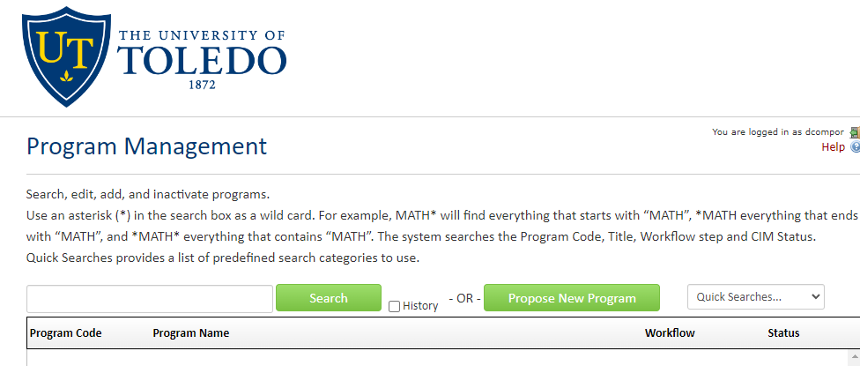

CLICK the Green Search Button, which pulls up all listed proposals in alphabetical order.

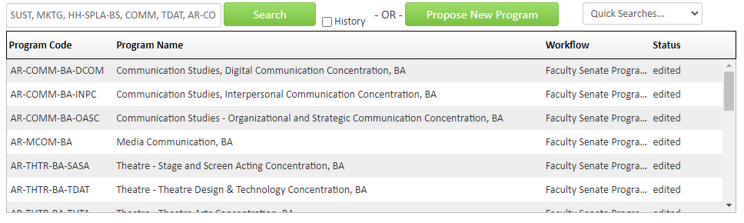
Only items that have Faculty Senate Programs under the Workflow tab have been endorsed by the committee.

SELECT A proposal to view. The list of proposals will remain at the top of the browser page.

