Faculty Senate

Academic Programs Committee

Report for April 9, 2024 Senate Meeting

The following proposals need to be reviewed by the Academic Programs Committee.

CLICK (or ENTER) this URL.

https://nextcatalog.utoledo.edu/programadmin/

COPY & PASTE this comma-delimited list into CIM programs search box.

BU-MGMT-BB

The full instruction sheet, with images, is still included at the end of this document.

Please send major concerns to the entire committee. Please send minor corrections to me directly. Daniel.compora@utoledo.edu

Management, BBA

- Deactivated the course MGMT 4210. Updated the Management program to reflect this.

- Changed contact person.
Instructions to View Original Proposal Files on CIM

# NPP New Program Proposal
# PCR Program Change Request

CIM changes summarized: Green is NEW, Red (strikeout) is OLD

ENTER this URL to see the actual proposal documents of programs

https://nextcatalog.utoledo.edu/programadmin/

COPY & PASTE the comma-delimited list into CIM programs search box.

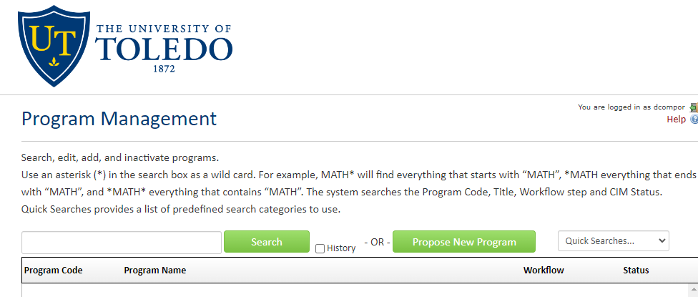

CLICK the Green Search Button, which pulls up all listed proposals in alphabetical order.

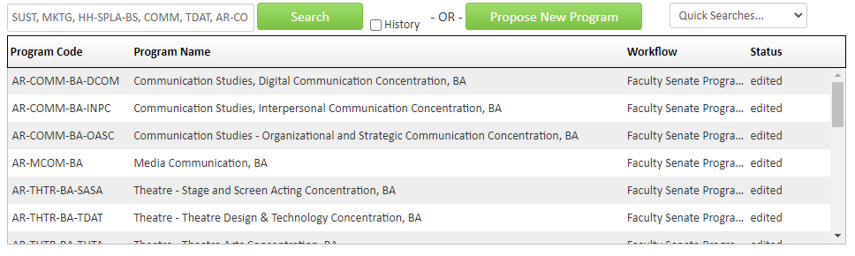
Only items that have Faculty Senate Programs under the Workflow tab have been endorsed by the committee.

SELECT A proposal to view. The list of proposals will remain at the top of the browser page.

