Council of Biomedical Graduate Students
12/13/2018 Meeting Minutes

Location: HEB 233
Start Time: 5:00pm
Present:
Cara DeAngelis, President
Josh Breidenbach, Vice President
Amit Chougule, Treasurer
Deepti Gurung, Publicist
Bri Zellner, MMI Rep
Chrysan Mohammed, MOME Rep
Kelsey Murphy, NND Rep
Robin Su, MD PhD Rep
Rajan Paudel, BIPG Rep

I. Call to Order

II. Old Business

III. New Business
- 2019 GRF:
We decided to extend the oral registration deadline to the same as the poster deadline – Jan. 18th, 2019
We didn’t really discuss anything else, just delved into making stockings, so these things need discussed at the next meeting
  - Draw 12 participants for Oral presentation
  - In touch with Dr. Janet Iwasa for travel reservations
  - Need to schedule simulation tour for her visit
  - GRF Responsibilities
  - GSA funding request for GRF
  - Room reservation mostly done

- 2020 GRF speaker –Dr. Nahum Sonenberg
- Need to pick dates for 2020 GRF

- Decorate Stockings!
  - Put names on each
  - Stuff with candy
  - Post on doors
Stockings were ordered in November by Kandace from amazon. Thank you Kandace! https://www.amazon.com/LimBridge-Mini-Christmas-Stockings-Decorating/dp/B01MAUBCXA/ref=sr_1_3?ie=UTF8&qid=1541458001&sr=8-3&keywords=mini%2Bchristmas%2Bstockings&th=1
We separated into groups, added names to stockings with sharpies and lab tape, and added mini candy canes, mints, reeses chocolate kisses and a message saying, “Don’t forget to register for GRF – Happy Holidays, CBGS”

Cara spent $23.88 on candy from Walmart (12/11/2018, copy of receipt given to Michelle Lindhorst)

We actually were short a few stockings and sacrificed a few of the CBGS members so that other students could get them. The list was missing Masters BIPG and Masters first years.
We put first year PhD student stockings in the room they have an exam tomorrow – HBSB 188
List we followed is below. If someone wasn’t listed or was no longer around, we added or removed them from the list.
PhD students |  |  | Beg of Award Yr #?
Name | Track | advisor
Abokor, Ahmed | MOME |  | 1
Hamoud, Abdul-Rizaq | MOME |  | 1
Harberson, Mitchell | MOME |  | 1
Breidenbach, Joshua | MMI | Haller/Kennedy | 1
Chakravarty, Sukanya | MMI |  | 1
Marino, Maxim | MMI |  | 1
Odeh, Hussain | MMI |  | 1
Tully, Brenden | MMI |  | 1
Fernado, Veani Roshale | CNBI |  | 1
(Jackson) Huang, Caoquinglong | CNBI |  | 1
Abel, Mackezie | NNDI |  | 1
Alganem, Khaled | NNDI |  | 1
Alnafisah, Rawan | MOME |  | 1
Bhattacharjee, Sayani | CNBI | Nadiminty | 2
Sugumaran Manon, Smrithi | MMIM | Ferreira | 2
Golonka, Rachel | MOME | Vijay-Kumar | 2
Edwards, Jonnelle | MOME | Wenceslau, Cammilla | 2
Ashraf, Usman | MOME | Kumurasamy | 3
Baroi, Sudipta | MOME | Lecka-Czernik | 3
Howard, Cory | CNBI | Raman | 3
Letson, Joshua | CNBI | Furuta | 3
Mohammed, Chrysan | MOME | Kennedy | 3
Sherman, Shermel | MOME | Hill | 3
Sridharan, Sangita | CNBI | Raman | 3
Syed, Irum | MMIM | Wooton | 3
Walia, Yashna | CNBI | Furuta | 3
Fout, Kelsey | MOME | Gupta | 3
Chougule, Amit | MOME | Lecka-Czernik | 4
Craig, Daniel | CNBI | Willey | 4
Tilley, Augustus | CNBI | Raman | 4
Subramanian, Gayatri | MMIM | Chattopadhyay | 4
Chen, Jin | MMIM | Ferreira | 4
Lad, Apurva | MMIM | Kennedy | 4
Zellner, Briana C. | MMIM | Huntley | 4
Khalaf, Fatimah Kareem | MOME | Kennedy | 4
Zhang, Shungang | MOME | Haller | 4
Chakraborty, Soroj | MOME | Bina Joe | 4
Murphy, Kelsey | NNDI | Park | 4
Kalpana, Gardiyawasam | CNBI | Yeung | 5
Al-Khudhair, Ahmed | MOME | Jaume | 5
Moledina, Muhammed Saad | MMIM | Wooten | 5
Deangelis, Cara | MMIM | Matson | 5
Fan, Xiaoming | MOME | Tian | 6
Saul, Jessica | MMIM | Matson | 6
Blaker, Amanda | NNDi | Yamomoto | 6
Nicholas Henkel | NND | MD/PhD Med school yr 1
Shumin Fan |  | MD/PhD Med school yr 2
Justin Franco |  | MD/PhD Med school yr 3
Michael McHugh |  | MD/PhD Med school yr 4
Creeden, Justin | NSND MD/PhD | Brunicardi/Shi-he Liu | 1
Moore, Sara | CNBI MD/PhD | Ferreira | 1
Becker, Katheryn | CNBI MD/PhD | Eisenmann | 1
Gorden, Darren | MOME MD/PhD | Hinds | 2
Su, Robin | CNBI MD/PhD | Kennedy | 2
Harless, Nicole | NSND MD PhD | X. Wang | 2
Dolin, Hallie | MMIM | Pan | 4
Galla (McMasters), Sarah | MOME | Joe | 4
Meikle, Claire | MMIM | Worth | 4
MSBS students
Gurung, Deepti | BIPG | Blunenthal
Paudel, Rajan | BIPG | Fedorov
Kaur, Prabhjot | BIPG | Khuder
Lasisi, Oluwatobi Ganiu (Tobi) | BIPG | Khuder
Peter, Cara | MMIM | Chakravarti

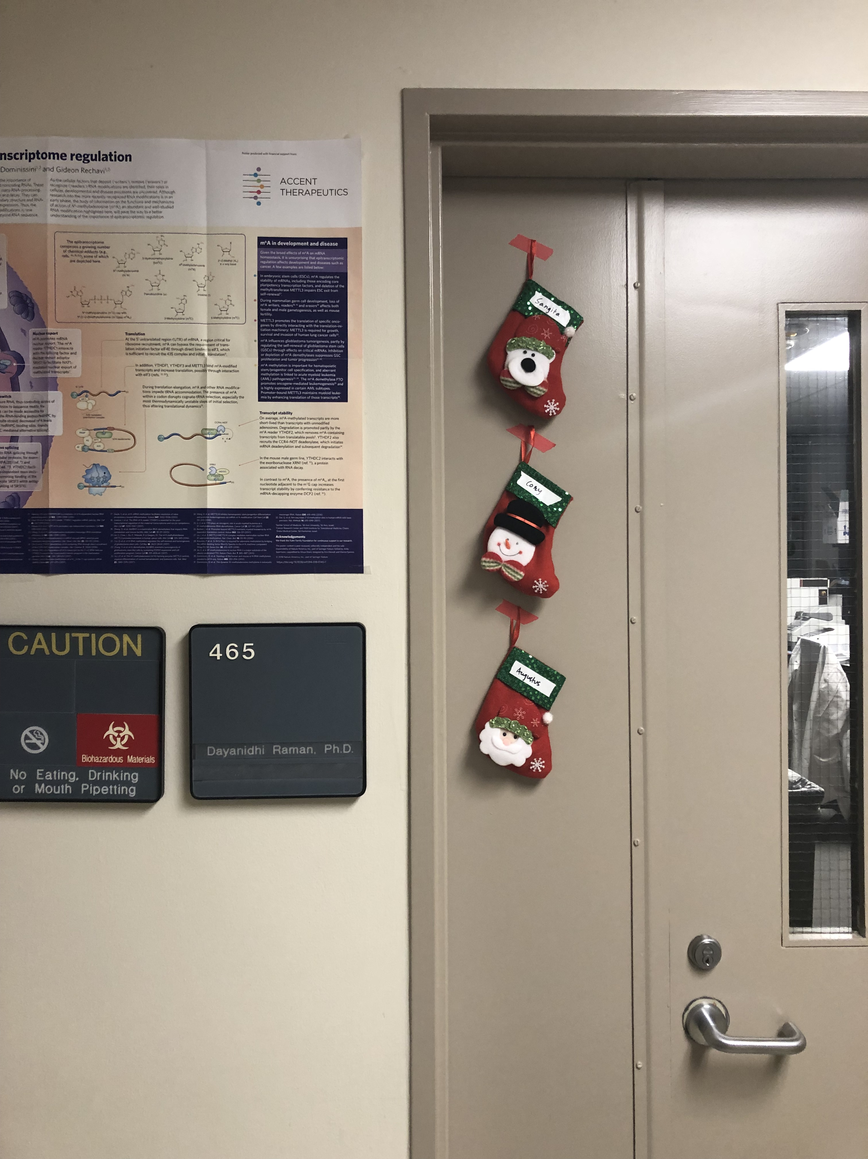

Next Meeting – January 17th 2019

IV. Adjournment
End Time: 5:35-6:00pm

